
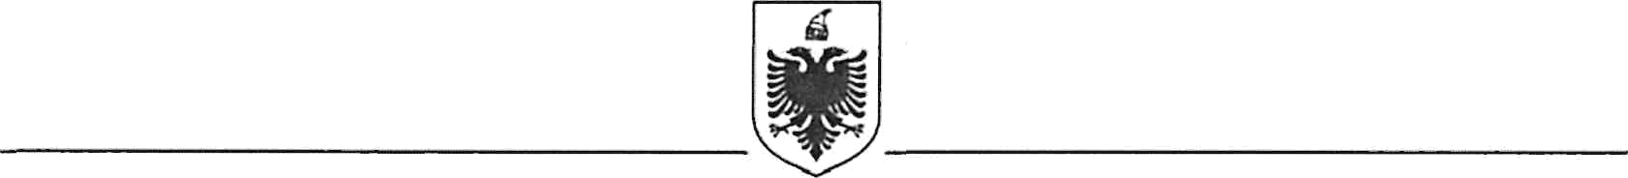
REPUBLIC OF ALBANIA
MINISTRY OF FINANCE
GENERAL DIRECTORATE FOR FINANCING ANND CONTRACTING OF EU, WORLD BANK AND OTHER DONORS FUNDS

Contract Award

Project Name: Strengthening Quality of Auditing and Reporting Project - Albania
Country: Albania
Project Number: TF No.: B5581

Report Period: 11.09.2024

Awarded Consultant: | Facilization Sh.p.k
Consultant’s Address: | Address: Rr. Sami Frashëri, P.56, Kompleksi TID, Hyrja B, Kati 1, Nj.B.5,Tirana, Albania  Mob.: +355 67 28 84 883  E-mail: gerd.hado@facilization.com
Contract Signature date: | 02 September 2024
Method of Procurement/Selection: | Consultants Qualification Selection Method (CQS)
Price: | 23,760 EUR (twenty-three thousand and seven hundred and sixty Euro)
Duration: | September 2024 – January 2025
Summary scope of contract: | The objective for this specific assignment is to enhance approximation with EU norms and application of international standards for corporate financial reporting in Albania. The program particularly focuses on transparent policy environment and effective institutional framework for corporate reporting. This assignment is a continuation of the improvement implemented from the EQ FINREP in the system of National Business Centre for filing and publication of the financial statements.

