
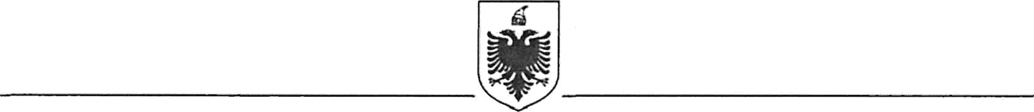
REPUBLIC OF ALBANIA
MINISTRY OF FINANCE
GENERAL DIRECTORATE FOR FINANCING ANND CONTRACTING OF EU, WORLD BANK AND OTHER DONORS FUNDS

Contract Award

Project Name: Strengthening Quality of Auditing and Reporting Project - Albania
Country: Albania
Project Number: TF No.: B5581

Report Period: 26.09.2024

Awarded Consultant: | Management Solutions
Consultant’s Address: | Address: Bockenheimer Landstraße 51-53  60325 Frankfurt am Main, Germany  Mob.: +49 69 79539480  E-mail: francisco.perez.calurano@msgermany.com.de
Contract Signature date: | 25 September 2024
Method of Procurement/Selection: | Consultants Qualification Selection Method (CQS)
Price: | 77.582 EUR (Seventy-Seven Thousand Five Hundred Eighty-Two Euro)
Duration: | 25 September 2024 – 25 September 2025
Summary scope of contract: | The consultant will provide technical support to the Bank of Albania for the development of a plan for building the supervisory challenging model and implement the preparation of a PD model for supervisory puroposes.

